President: Peter G. Burk
Vice President: Guy Beck
Clerk: Margaret Guyette
Commissioners: Scott Beiler
Peter Burk
Treasurer: Scott Wyllie
SHAKER PINES FIRE DISTRICT #5
A regular meeting of the Shaker Pines Fire District was held on Tuesday, July 9, 2024 at the fire station.
Those present were Vice President Guy Beck, Clerk Margaret Guyette, Commissioner Scott Beiler, Treasurer Scott Wyllie, Fire Chief James Nolan, Deputy Fire Chief Edward Prajzner, and Administrative Assistant Jolene Bauckman.
Vice President Beck called the meeting to order at 7:10 PM.
MINUTES: The minutes for June 2024 were presented to the Board members. A motion to accept the minutes was made by Commissioner Beiler and Vice President Beck made a second to the motion. A vote was taken, it was unanimous, and the motion carried.
TREASURER’S REPORT: Treasurer Wyllie submitted the treasurer’s report for June 2024 to the Board members. A motion to accept the treasurer's report was made by Commissioner Beiler and Vice President Beck made a second to the motion. A vote was taken, it was unanimous, and the motion carried.
CORRESPONDENCE: We received no correspondence.
FIRE CHIEF REPORT: Fire Chief Nolan submitted his report verbally. The A and B Shift crews have almost completed painting the district’s hydrants.
Fire department materials that were being stored at 100 Print Shop Road have been removed.
On July 1, 2024, the A and B Shifts swapped so that the A Shift is now on duty Thursday, Friday and Saturday and the B Shift is on duty Sunday, Monday and Tuesday with both shifts alternating Wednesday.
The department has received new computers and iPads that are now in service.
We have two quotes for HVAC service contracts for one year. Chief Nolan recommends staying with the current company.
The bollards protecting the transformer behind the building are sinking into the ground and will need to be dug out and reset with stones beneath them. Only one company responded to a request for quotes, and the quote was for about $5,700.
Both shifts participated in several Fourth of July parades in the area as well as the extrication demo that was part of the Enfield Fourth of July Celebration.
FIRE MARSHALL REPORT: Deputy Chief Prajzner read the report and it was placed on file. We had 68 incidents, 1 plan review, and 1 inspection. The plan review was at 555 Taylor Road. The monthly fire drill at LEGO Creative Child Care was conducted.
REPORTS OF COMMITTEES: Vice President Beck gave a summary from the Consolidation Committee. A meeting was held June 20, 2024. The committee continues to consider candidates for the Project Coordinator position. The next meeting will be July 18, 2024 at 6:30 PM at the North Thompsonville station.
OLD BUSINESS: There was no old business to discuss.
NEW BUSINESS: Clerk Guyette made a motion to accept the HVAC contract with the current company, Air Temp Mechanical. Commissioner Beiler made a second to the motion. A vote was taken, it was unanimous, and the motion carried.
Commissioner Beiler made a motion to spend no more than $6,000 to reset the bollards around the transformer. Vice President Beck made a second to the motion and a vote was taken. It was unanimous and the motion carried.
BILLS: The Board members reviewed the bills. A motion to pay the bills as submitted was made by Commissioner Beiler and Vice President Beck made a second to the motion. A vote was taken, it was unanimous, and the motion carried.
Clerk Guyette made a motion to go into Executive Session. Vice President Beck made a second to the motion, and a vote was taken. It was unanimous and the committee went into Executive Session. Chief Nolan and Deputy Chief Prajzner were invited into the session to discuss a personnel matter.
ADJOURNMENT: A motion to adjourn the meeting was made by Commissioner Beiler and Vice President Beck made a second to the motion. A vote was taken, it was unanimous, and the motion carried. The meeting adjourned at 7:54 PM.

Respectfully submitted,
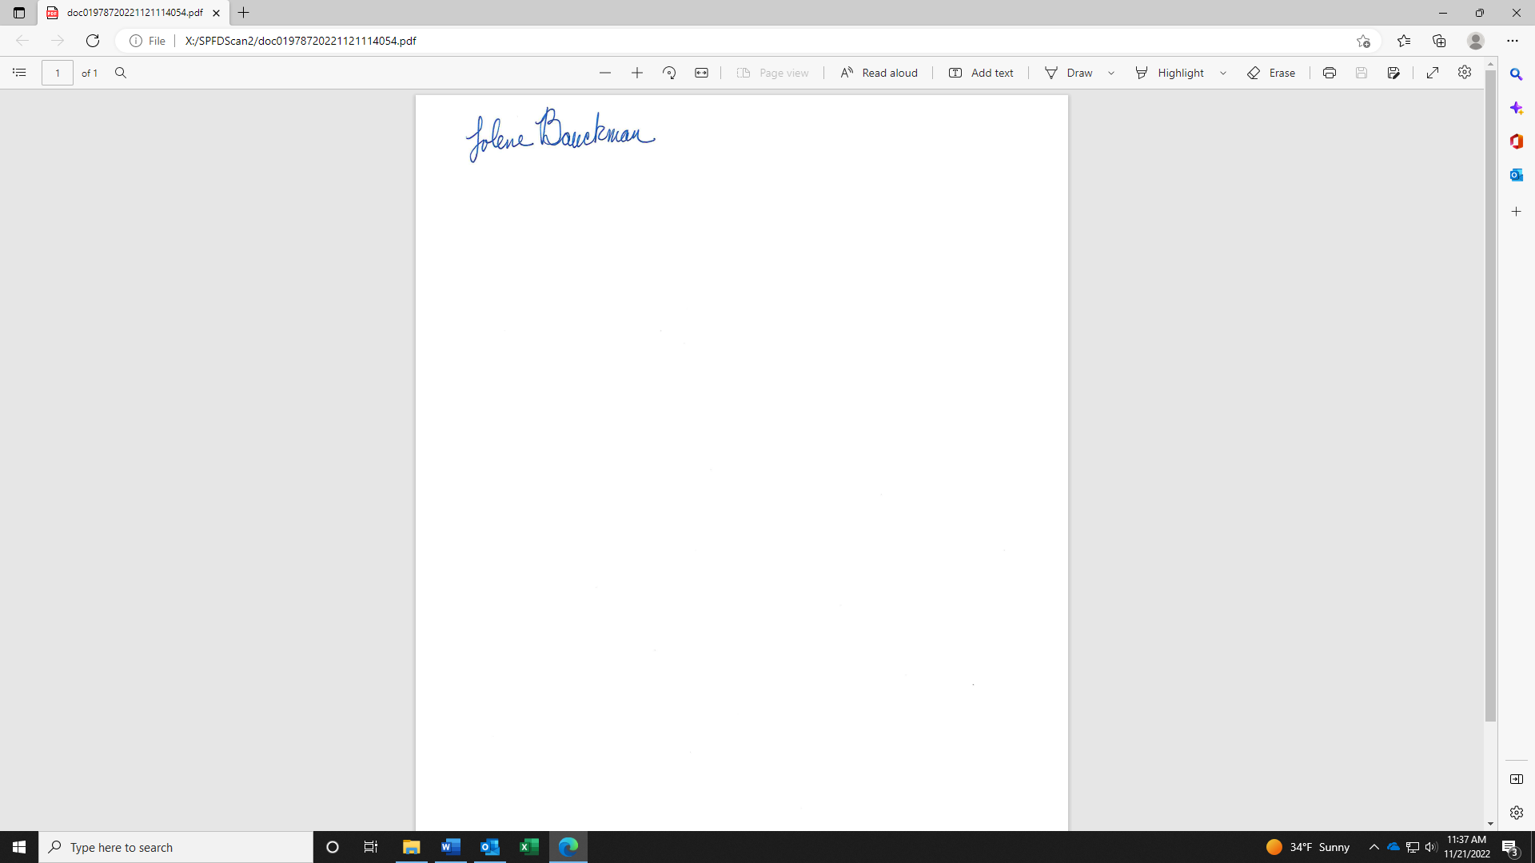
Jolene Bauckman
Administrative Assistant

