President: Peter G. Burk
Vice President: Guy Beck
Clerk: Margaret Guyette
Commissioners: Scott Beiler
Peter Burk
Treasurer: Glen Bentz
Scott Wyllie
SHAKER PINES FIRE DISTRICT #5
A regular meeting of the Shaker Pines Fire District was held on Tuesday, June 12, 2024 at the fire station.
Those present were President Peter G. Burk, Vice President Guy Beck, Clerk Margaret Guyette, Commissioner Peter Burk, Commissioner Scott Beiler, Treasurer Glen Bentz, Fire Chief James Nolan, Deputy Fire Chief Edward Prajzner, and Administrative Assistant Jolene Bauckman.
President Burk called the meeting to order at 7:00 PM.
MINUTES: The minutes for May 7, 2024 were presented to the Board members. A motion to accept the minutes was made by Vice President Beck and Commissioner Burk made a second to the motion. A vote was taken, it was unanimous, and the motion carried.
The minutes for the Annual Meeting held May 14, 2024 were presented to the Board members. A motion to accept the minutes was made by Vice President Beck and Commissioner Beiler made a second to the motion. A vote was taken, it was unanimous, and the motion carried.
TREASURER’S REPORT: Administrative Assistant Bauckman distributed the treasurer’s report prepared by Treasurer Wyllie for May 2024 to the Board members. A motion to accept the treasurer's report was made by Vice President Beck and Commissioner Burk made a second to the motion. A vote was taken, it was unanimous, and the motion carried.
CORRESPONDENCE: Clerk Guyette prepared an Income/Expense analysis for the cell phone tower which was required by the Town of Enfield.
Treasurer Wyllie has submitted the necessary paperwork to become a signer on the Peoples’ Bank accounts.
We have received and completed letters of engagement from PKF O’Connor Davies in preparation for the 2023-2024 general audit.
FIRE CHIEF REPORT: Fire Chief Nolan submitted his report verbally.
We received a $6,403 grant on June 3, 2024 from the State of CT. We also received a grant of 24 combination smoke and carbon monoxide detectors from the State Fire Marshal office.
The new air packs have been put into service.
Members from Shaker Pines participated in live fire training at the Somers Fire Department. In addition to the training facility, Somers Fire Department also provided staff and instructors for the training.
Hydrant painting has begun, and 2 of 3 broken hydrants have been replaced. Completion of the third will require coordination with Eversource.
One of the part-time firefighters has moved away, but a new probationary member, Kaine Armstrong, will start training soon.
On July 1, 2024, our A and B shifts will swap so that the A shift will be on duty every Thursday, Friday and Saturday. The B shift will be on duty every Sunday, Monday and Tuesday. The A and B shifts will continue to alternate Wednesdays. Deputy Chief Prajzner will return to a Monday-Friday schedule, and Firefighter Matt Gagnon will join the A shift in his place.
FIRE MARSHALL REPORT: Deputy Chief Prajzner read the report and it was placed on file. We had 72 incidents, 4 site reviews and 2 plan reviews. The plan reviews were at 215 Moody Road and at USA Hauling. The monthly fire drill at LEGO Creative Child Care was conducted.
REPORTS OF COMMITTEES: Vice President Beck gave a summary from the Consolidation Committee. A meeting was held on May 23, 2024. A possible project coordinator was interviewed. The candidate will present a proposal at the next meeting, and the committee will be considering at least one other candidate. Vice President Beck was contacted by one of the attorneys to discuss a start date for the beginning of consolidation efforts between the five districts and noted that new letters of engagement would be needed for the five districts as well. The next meeting will be held June 20, 2024 at the Thompsonville station.
President Burk gave a summary from the Tax Collection Committee. The committee met with the Town Council on June 3, 2024 to discuss the rate we pay to the town for tax collection.
OLD BUSINESS: There was no old business to address.
NEW BUSINESS: President Burk congratulated Treasurer Bentz on his retirement from service to the district and thanked him for his many years of work and friendship. Treasurer Bentz thanked the Board for the opportunity and promises to visit often. We all wish Treasurer Bentz many happy and safe travels.
Vice President Beck asked the secretary to cast one vote to keep the existing slate of officers for the 2024-2025 year. Commissioner Burk made a second to the motion, a vote was taken and the motion carried. The officers for 2024-2025 are: President Peter G. Burk, Vice President Guy Beck and Clerk Margaret Guyette.
BILLS: The Board members reviewed the bills. A motion to pay the bills as submitted was made by President Burk and Commissioner Beiler made a second to the motion. A vote was taken, it was unanimous, and the motion carried.
ADJOURNMENT: A motion to adjourn the meeting was made by Treasurer Bentz and Vice President Beck made a second to the motion. A vote was taken, it was unanimous, and the motion carried. The meeting adjourned at 8:00 PM.

Respectfully submitted,
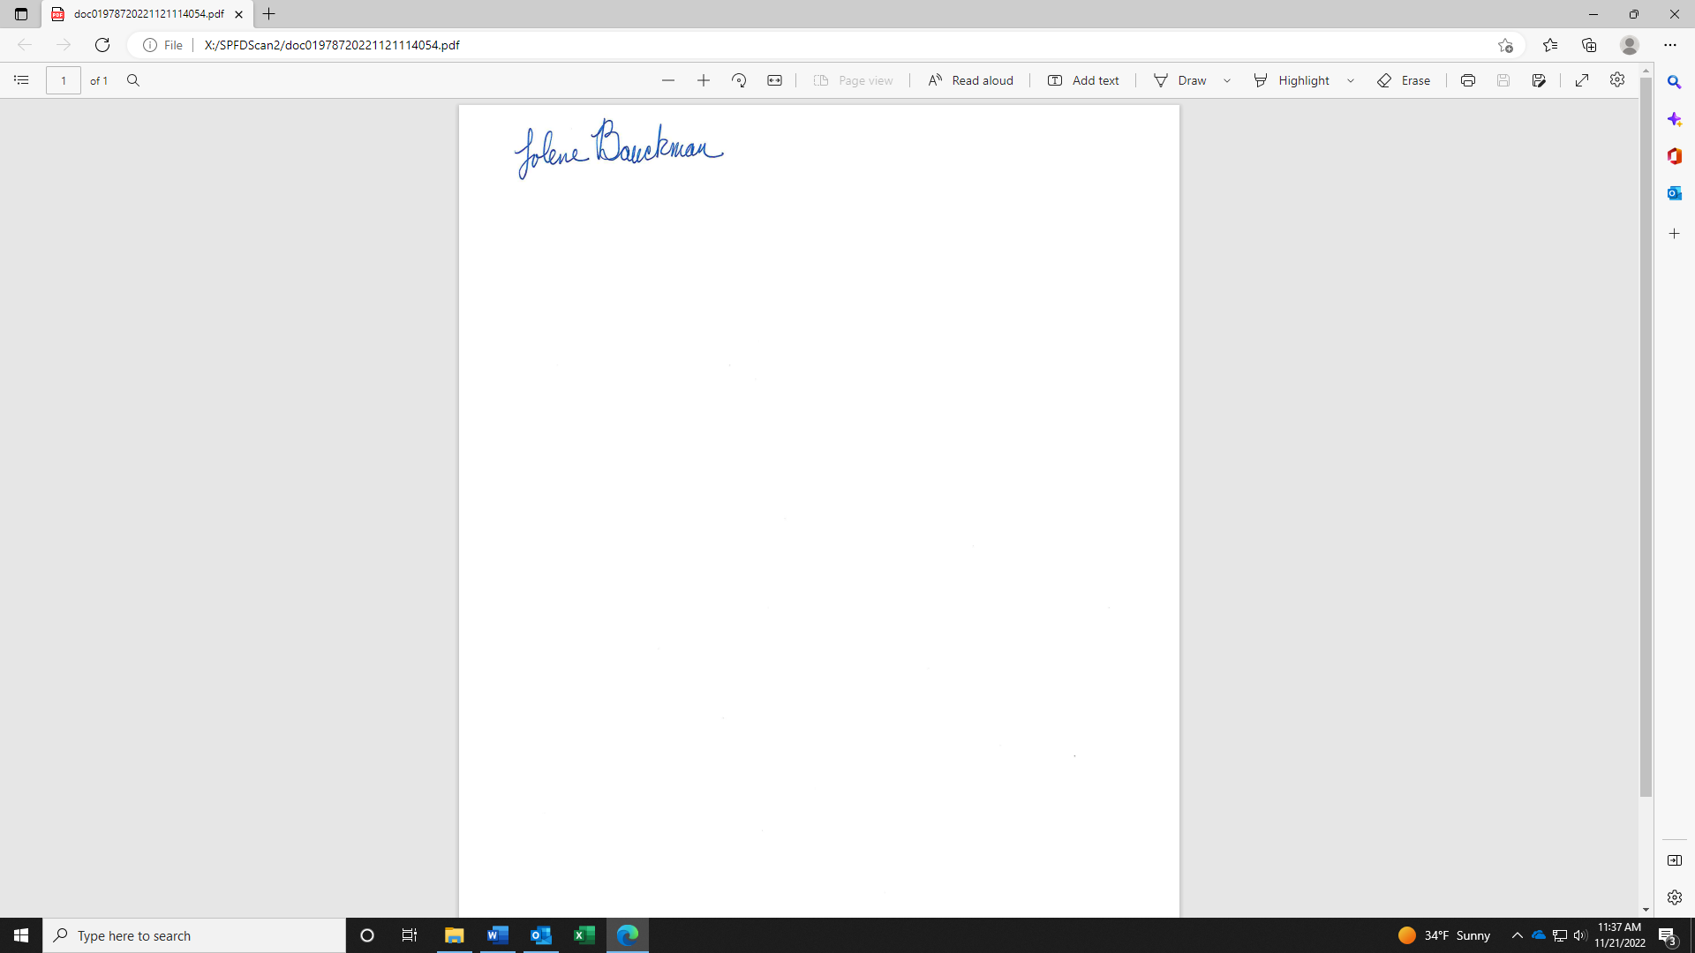
Jolene Bauckman
Administrative Assistant

