President: Peter G. Burk
Vice President: Guy Beck
Clerk: Margaret Guyette
Commissioners: Scott Beiler
Peter Burk
Treasurer: Scott Wyllie
SHAKER PINES FIRE DISTRICT #5
A regular meeting of the Shaker Pines Fire District was held on Tuesday, August 13, 2024 at the fire station.
Those present were President Peter G. Burk, Vice President Guy Beck, Clerk Margaret Guyette, Commissioner Scott Beiler, Treasurer Scott Wyllie, Fire Chief James Nolan, Deputy Fire Chief Edward Prajzner, and Administrative Assistant Jolene Bauckman.
President Burk called the meeting to order at 7:00 PM.
MINUTES: The minutes for July 2024 were presented to the Board members. A motion to accept the minutes was made by Vice President Beck and President Burk made a second to the motion. A vote was taken, it was unanimous, and the motion carried.
The minutes for the special meeting held July 25, 2024 were presented to the Board members. A motion to accept the minutes was made by Vice President Beck and President Burk made a second to the motion. A vote was taken, it was unanimous, and the motion carried.
TREASURER’S REPORT: Treasurer Wyllie submitted the treasurer’s report for July 2024 to the Board members. A motion to accept the treasurer's report was made by Vice President Beck and Commissioner Beiler made a second to the motion. A vote was taken, it was unanimous, and the motion carried.
CORRESPONDENCE: We received no correspondence.
FIRE CHIEF REPORT: Fire Chief Nolan submitted his report verbally.
The annual pump test and planned maintenance was performed on Engine 52, and Engine 51 was dropped off for the same service.
One of our volunteers has moved on to attend medical school, and another potential volunteer has joined.
Firefighter Sheldon has returned from military service, and we welcomed her back into fire service. Firefighter Kober, however, will be away on military service until mid-September.
There is a new benefit through EAP that will help with mental health.
Members of the department participated in the National Night Out with the police department on August 6, 2024.
FIRE MARSHALL REPORT: Deputy Chief Prajzner read the report and it was placed on file. We had 71 incidents, 1 plan review at 215 Moody Road, and 1 inspection. The monthly fire drill at LEGO Creative Child Care was conducted. Deputy Chief Prajzner completed 16.5 hours of training.
REPORTS OF COMMITTEES: Vice President Beck gave an update from the Consolidation Committee. The last meeting took place on July 18, 2024. The committee continues to communicate with potential project coordinators and clarify what that role will entail. The next meeting will be August 22, 2024 at 6:30 PM at the Shaker Pines station.
President Burk gave an update on tax collection. The group is considering next steps as consolidation moves forward, and they are also considering a proposed tax collection rate for the future.
OLD BUSINESS: There was no old business to discuss.
NEW BUSINESS: We received a motor vehicle tax grant from the State of CT in the amount of $92,863.27.
Commissioner Beiler will invite a representative to the September 10, 2024 monthly meeting to propose installing solar panels at the station. The meeting time will be changed to 6:30 PM.
BILLS: The Board members reviewed the bills. A motion to pay the bills as submitted was made by President Burk and Vice President Beck made a second to the motion. A vote was taken, it was unanimous, and the motion carried.
Vice President Beck made a motion to enter executive session to discuss a personnel matter. Commissioner Beiler made a second to the motion. A vote was taken, it was unanimous, and the board went into executive session. Chief Nolan and Deputy Chief Prajzner were invited into the executive session.
ADJOURNMENT: A motion to adjourn the meeting was made by Commissioner Guyette and Commissioner Beiler made a second to the motion. A vote was taken, it was unanimous, and the motion carried. The meeting adjourned at 7:57 PM.

Respectfully submitted,
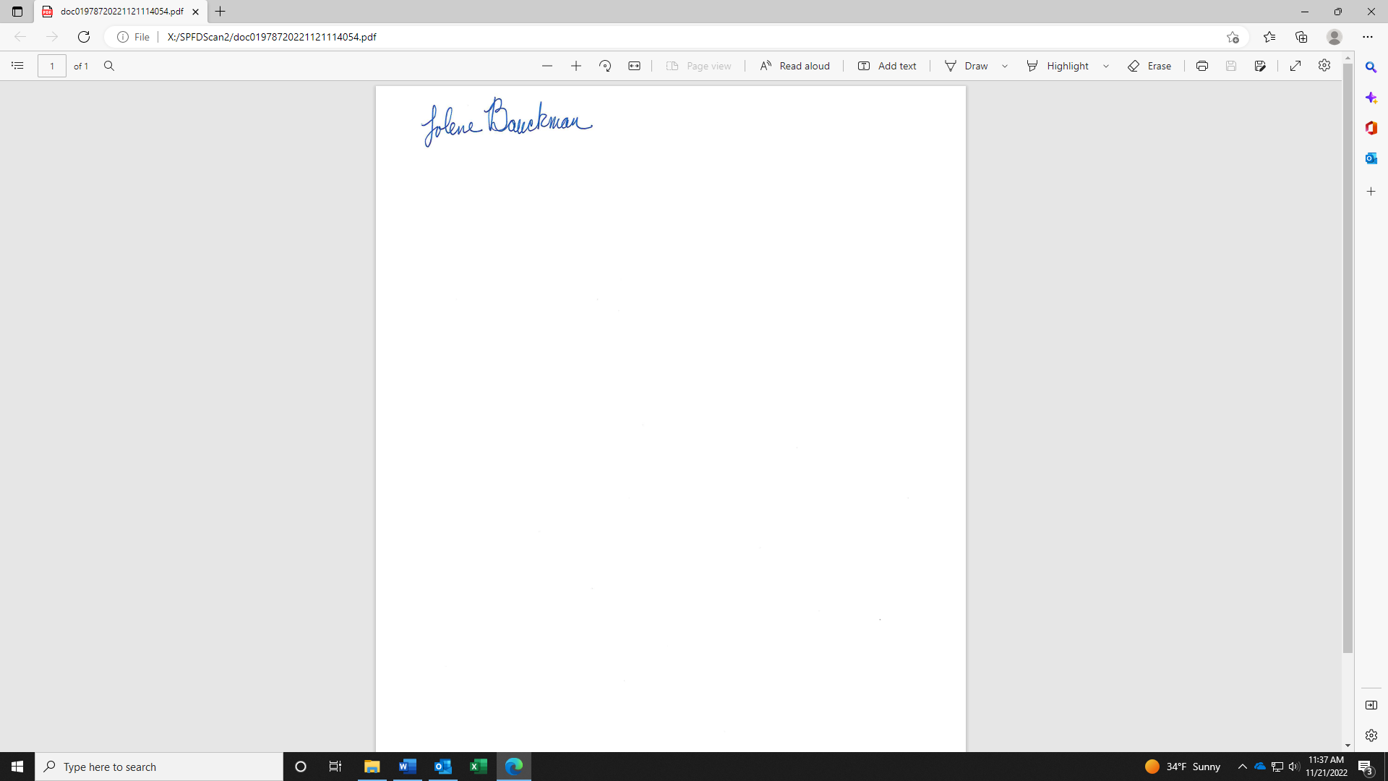
Jolene Bauckman
Administrative Assistant

