President: Peter G. Burk
Vice President: Guy Beck
Clerk: Margaret Guyette
Commissioners: Scott Beiler
Peter Burk
Treasurer: Scott Wyllie
SHAKER PINES FIRE DISTRICT #5
A regular meeting of the Shaker Pines Fire District was held on Tuesday, September 10, 2024 at the fire station.
Those present were President Peter G. Burk, Vice President Guy Beck, Clerk Margaret Guyette, Commissioner Peter Burk, Commissioner Scott Beiler, Treasurer Scott Wyllie, Fire Chief James Nolan, Deputy Fire Chief Edward Prajzner, and Administrative Assistant Jolene Bauckman.
President Burk called the meeting to order at 7:04 PM.
MINUTES: The minutes for August 2024 were presented to the Board members. A motion to accept the minutes was made by Vice President Beck and Commissioner Burk made a second to the motion. A vote was taken, it was unanimous, and the motion carried.
TREASURER’S REPORT: Treasurer Wyllie submitted the treasurer’s report for August 2024 to the Board members. A motion to accept the treasurer's report was made by Clerk Guyette and President Burk made a second to the motion. A vote was taken, it was unanimous, and the motion carried. The treasurer will open 3 new CDs with the tax check received from the town.
CORRESPONDENCE: We received no correspondence.
FIRE CHIEF REPORT: Fire Chief Nolan submitted his report verbally. We received the annual tax income check from the Town of Enfield in the amount of $1,889,925.72.
The workers compensation audit is complete, and we are awaiting the final report.
Training: We are hosting a CT Fire Academy Pump class at the station for three weekends. Firefighters Lundie and Davis are both taking the course. Firefighters Gagnon and Smyth are both taking the Firefighter II course at the Academy, while Probationary Member Armstrong is taking Firefighter I. New member Ilijah Mark has joined the department and will hopefully attend Firefighter I in the Spring. Firefighters Gagnon and Davis have completed the department’s driver training.
Firefighter Kober will return to service from military leave next week.
FIRE MARSHALL REPORT: Deputy Chief Prajzner read the report and it was placed on file. We had 110 incidents, 1 plan review at 215 Moody Road, and 2 inspections. The monthly fire drill at LEGO Creative Child Care was conducted. Deputy Chief Prajzner completed 3 hours of training.
REPORTS OF COMMITTEES: Vice President Beck gave an update from the consolidation committee. The last meeting was held on August 28, 2024, with attorneys present. Two resolutions will be presented: the first will be for each board of commissioners to approve the start of consolidation efforts. The second will be for the taxpayers to approve the same. Once both resolutions are approved, the committee will have 18 months to complete the process. The committee is still considering options for the coordinator role. The next meeting will be held at the Hazardville Station on October 3, 2024.
President Burk gave an update about tax collection. They will be meeting with representatives from the Town of Enfield on Thursday, September 12, 2024.
OLD BUSINESS: The representative to propose the installation of solar panels at the station is no longer available, so the matter has been tabled.
NEW BUSINESS: There was no new business to discuss.
BILLS: The Board members reviewed the bills. A motion to pay the bills as submitted was made by Vice President Beck and Commissioner Burk made a second to the motion. A vote was taken, it was unanimous, and the motion carried.
ADJOURNMENT: A motion to adjourn the meeting was made by President Burk and Vice President Beck made a second to the motion. A vote was taken, it was unanimous, and the motion carried. The meeting adjourned at 7:39 PM.

Respectfully submitted,
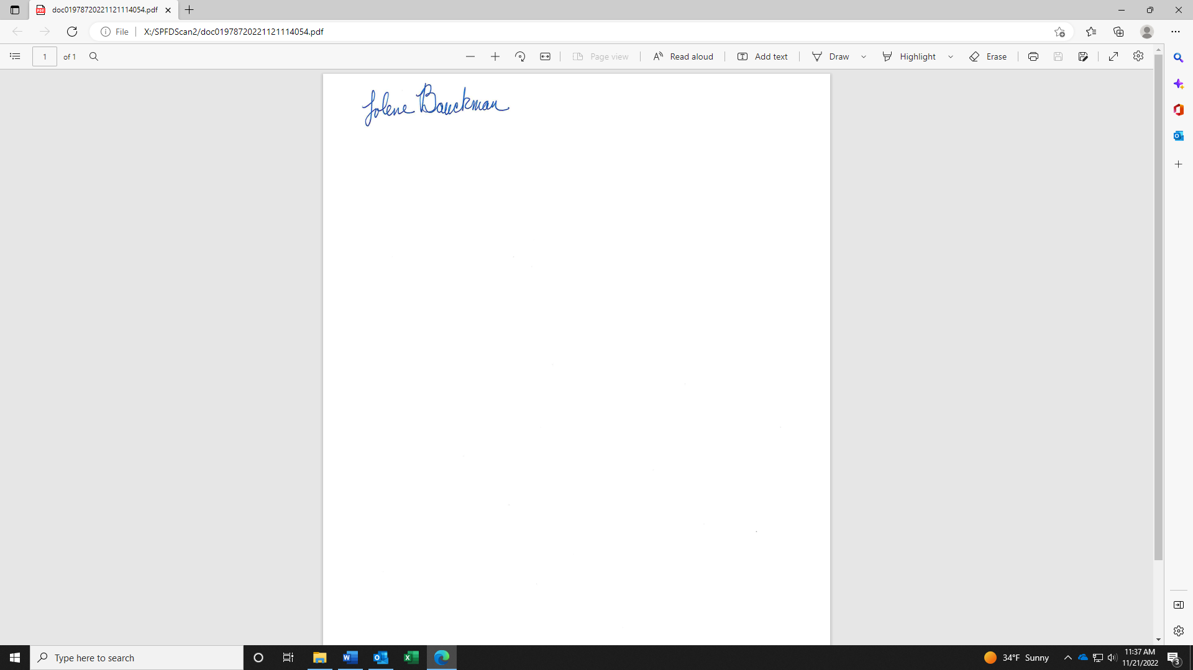
Jolene Bauckman
Administrative Assistant

