President: Peter G. Burk
Vice President: Guy Beck
Clerk: Margaret Guyette
Commissioners: Scott Beiler
Peter Burk
Treasurer: Scott Wyllie
SHAKER PINES FIRE DISTRICT #5
A regular meeting of the Shaker Pines Fire District was held on Tuesday, October 8, 2024 at the fire station.
Those present were President Peter G. Burk, Vice President Guy Beck, Clerk Margaret Guyette, Commissioner Peter Burk, Deputy Fire Chief Edward Prajzner, and Administrative Assistant Jolene Bauckman.
President Burk called the meeting to order at 7:05 PM.
MINUTES: The minutes for September 2024 were presented to the Board members. A motion to accept the minutes was made by Vice President Beck and President Burk made a second to the motion. A vote was taken, it was unanimous, and the motion carried.
TREASURER’S REPORT: Treasurer Wyllie prepared the treasurer’s report which was distributed by Administrative Assistant Bauckman for September 2024 to the Board members. A motion to accept the treasurer's report was made by Vice President Beck and Commissioner Burk made a second to the motion. A vote was taken, it was unanimous, and the motion carried.
CORRESPONDENCE: We received a letter of thanks from the sister of a resident who has been helped by the department recently. The letter was placed on record.
FIRE CHIEF REPORT: Deputy Chief Prajzner submitted the report verbally. The department participated in the town-wide fire departments’ Open House event. It was well-attended and several guests showed interest in joining the department.
Members of the department participated in the Four Town Fair parade.
Newport Group, which handles the department’s retirement plan, will become Ascensus in November. We don’t anticipate any issues with migration to the new company.
Members of the department participated in a town-wide training on thermal imaging.
On October 24, 2024, we have been invited to participate in Life Star training at the Senior Center which will include a landing and loading demonstration.
The annual workers compensation plan audit is complete, and our rates have been adjusted accordingly.
FIRE MARSHALL REPORT: Deputy Chief Prajzner read the report and it was placed on file. We had 100 incidents, and 92 inspections, which included 85 at Mayfield Place apartments. The monthly fire drill at LEGO Creative Child Care was conducted. Completed training was as follows: Chief Nolan – 8 hours, Deputy Chief Prajzner – 11 hours, Captain Mele – 8 hours, Captain Davis – 16 hours.
REPORTS OF COMMITTEES: Vice President Beck gave an update from the consolidation committee. All of the districts have a letter of engagement to be signed for legal representation. Shaker Pines has uploaded the bylaws to the shared Microsoft Teams. A resolution has been drafted for each of the five districts to consider consolidation. It will need to be approved by all of the commissioners in each district. The Shaker Pines commissioners will hold a special meeting on October 21, 2024 for the purpose of approving the resolution. The next meeting will be held October 24, 2024 at Enfield Fire District #1.
President Burk gave an update from the tax collection committee. The group has been discussing a proposal that will be presented to the town.
OLD BUSINESS: There was no old business to discuss.
NEW BUSINESS: There was no new business to discuss.
BILLS: The Board members reviewed the bills. A motion to pay the bills as submitted was made by President Burk and Vice President Beck made a second to the motion. A vote was taken, it was unanimous, and the motion carried.
ADJOURNMENT: A motion to adjourn the meeting was made by Vice President Beck and President Burk made a second to the motion. A vote was taken, it was unanimous, and the motion carried. The meeting adjourned at 7:35 PM.

Respectfully submitted,
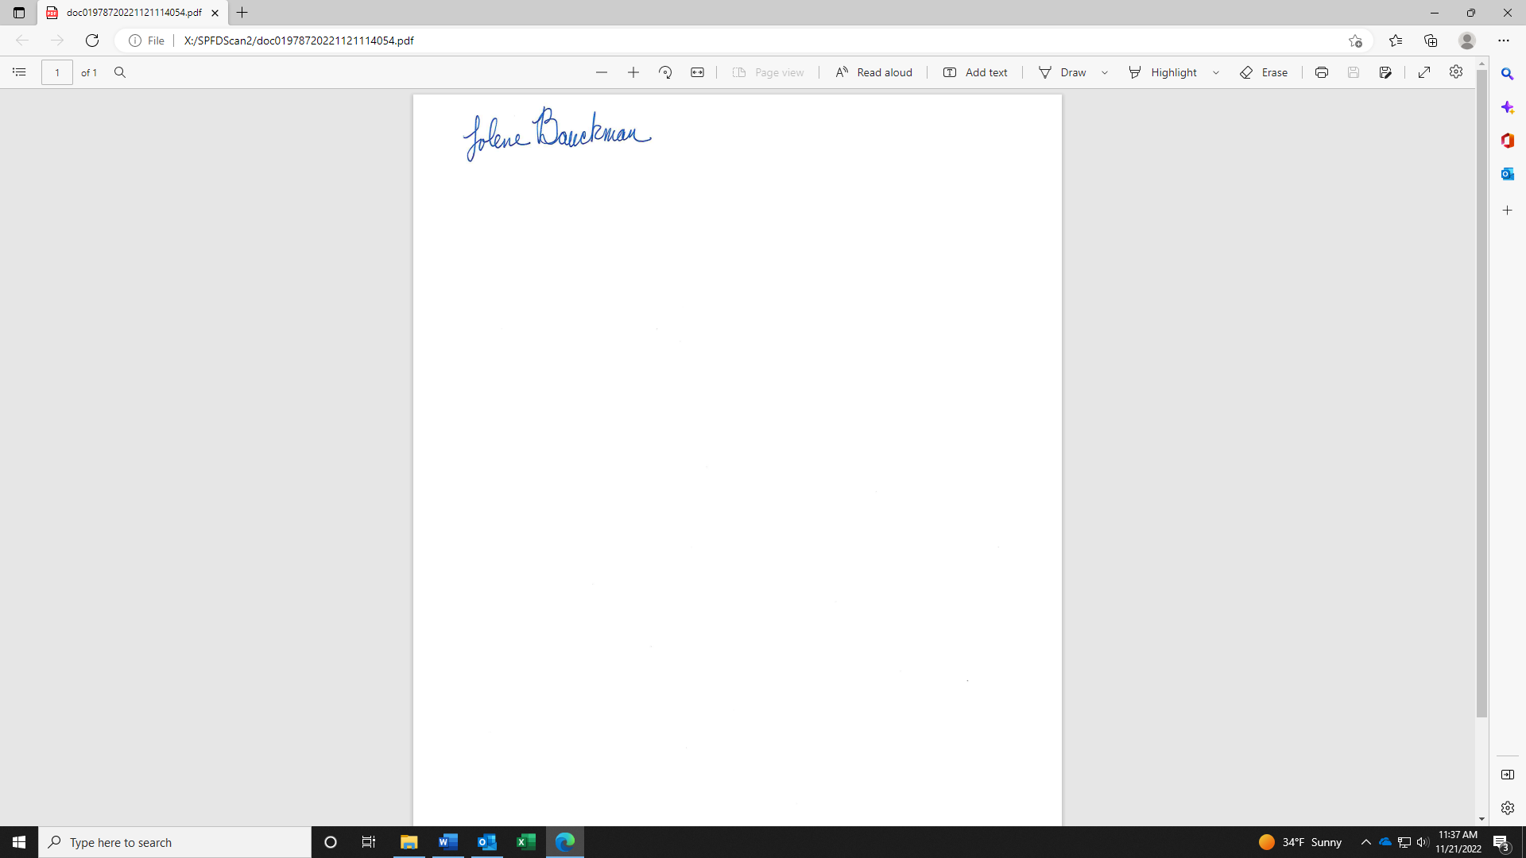
Jolene Bauckman
Administrative Assistant

